

GHULAM ISHAQ KHAN INSTITUTE OF ENGINEERING SCIENCES AND TECHNOLOGY

PROJECT PROPOSAL

Email-based Remote Server Monitoring System

Submitted to:
Miss Umme Rubab

Team Members:
Momin Taj - 2024309
Munawar Wahab - 2024501
Abdul Muqeet - 2024016
Fahad Rehman - 2024377

1. Introduction
Modern computing infrastructure forms the backbone of virtually every institution — from universities and hospitals to startups and government agencies. Servers running applications, databases, and networking services must remain stable, secure, and performant at all times. Yet many organizations, particularly smaller ones, lack robust, real-time visibility into what is happening on their servers.

The Email-based Remote Server Monitoring System is a database-driven solution designed to bridge this gap. By continuously collecting server performance metrics — CPU usage, memory consumption, disk I/O, and error events — storing them in a structured relational database, and triggering email alerts when thresholds are exceeded, the system delivers immediate awareness to administrators without requiring them to be logged in or even at their desk.

This project is developed as the semester deliverable for CS232: Introduction to Databases. It satisfies all project milestones: a clearly identified business scenario, a normalized relational schema, sample data, meaningful SQL queries, and a functional user interface prototype. Beyond the academic requirements, the system is architected to reflect real-world engineering decisions — transaction control, indexing strategy, role-based access, and third-party API integration.

2. Vision
Our vision is to build a lightweight yet production-grade server monitoring platform that democratizes infrastructure awareness. The system targets institutions and teams that cannot afford enterprise monitoring suites but still need reliable, instant notifications when something goes wrong.

▌ Core Vision Pillars
- Real-time awareness: email notifications reach administrators within seconds of a threshold breach — no screen-watching required.
- Data-driven diagnostics: Every metric and event is persisted so teams can query historical trends, identify recurring issues, and plan capacity upgrades.
- Simplicity first: Administrators should understand the system at a glance without specialized training or expensive tooling.
- Extensibility: The schema and backend are designed so that new servers, new alert channels (email, WhatsApp), or new metric types can be added with minimal rework.

3. Competitive Analysis
Several monitoring tools exist in the market. The table below positions our system against the most common alternatives:

Tool / System | How Our System Differs
Nagios | Enterprise-grade but demands complex configuration. No native email alerting and no relational DB design exercise.
Datadog | Cloud-hosted SaaS with per-host pricing that puts it out of reach for students and small organizations.
Zabbix | Open-source and powerful but carries a steep learning curve.
Prometheus + Grafana | Excellent visualization stack built on a time-series DB.
Our System | Purpose-built relational schema (PostgreSQL), Nodemailer/Gmail email alerts triggered by DB events, full normalization documentation, rich query library, and a simple UI — a single cohesive academic and practical deliverable.

4. Technical Approach

▌ 4.1 Architecture Overview
The system follows a three-tier architecture: a backend metrics collector, a relational database layer, and a frontend dashboard. A scheduled agent on each monitored server collects metrics at configurable intervals and sends them via HTTP to the backend. The backend validates, normalizes, and inserts data into the database, then evaluates alert rules through PostgreSQL triggers rather than application-level polling.

▌ 4.2 Database Design
The relational database will contain at minimum the following entities:
- Servers: Stores registered servers including hostname, IP address, environment tag, and owner.
- Metrics: Time-stamped CPU, memory, disk, and network readings per server.
- AlertRules: Configurable thresholds per metric type per server, with severity levels.
- AlertEvents: Log of every triggered alert: timestamp, severity, metric value, and rule breached.
- Personnel: Administrators and their email addresses for alert routing.
- EmailLog: Record of every dispatched message — the deduplication anchor for transaction control.

The schema will be normalized to at least 3NF. Indexes will be placed on high-cardinality columns used in WHERE clauses (server_id, timestamp, severity) to support rapid diagnostic queries.

▌ 4.3 Technologies to be used

Component | Technology & Rationale
Backend | Node.js (Express)
Database | PostgreSQL
Email Gateway | Nodemailer + Gmail
Frontend UI | React.js
Version Control | Git / GitHub
Testing | Jest

▌ 4.4 Key SQL Features
- AFTER INSERT triggers on Metrics for real-time alert evaluation
- Stored procedures for bulk metric ingestion and cooldown-aware alert dispatch
- Aggregate queries for trend reports: average CPU over 24 h, peak memory by server, alert frequency
- Atomic transactions that write AlertEvent and EmailLog together, preventing partial alert states
- Indexed views for the dashboard to serve sub-second query responses

5. Requirements and Features

▌ 5.1 Functional Requirements
- Register and manage multiple monitored servers in the database
- Collect and persist CPU, memory, disk, and network metrics on a configurable schedule
- Define alert rules per server covering metric type, threshold value, and severity level
- Automatically dispatch email notifications when alert rules are violated
- Prevent duplicate alerts using cooldown windows enforced through database transactions
- Display a real-time dashboard with color-coded server health status (green / yellow / red)
- Generate historical reports: metric trend graphs, top-N error events, downtime summaries
- Support role-based access: admin (full control) and viewer (read-only dashboard)

▌ 5.2 Non-Functional Requirements
- Alert email delivered within 30 seconds of threshold breach
- Dashboard queries must return within 2 seconds for up to 10 monitored servers
- Schema normalized to 3NF minimum; BCNF achieved wherever practical
- Codebase version-controlled on GitHub with a meaningful, readable commit history
- Final documentation covers ERD, normalization steps, all SQL queries, and system architecture

6. Entity Relationship Diagram
The diagram below presents the full ERD for the Email-based Remote Server Monitoring System using crow's foot notation. Each entity maps directly to a relational table in the PostgreSQL database. Primary keys (PK) uniquely identify each record; foreign keys (FK) enforce referential integrity across tables.

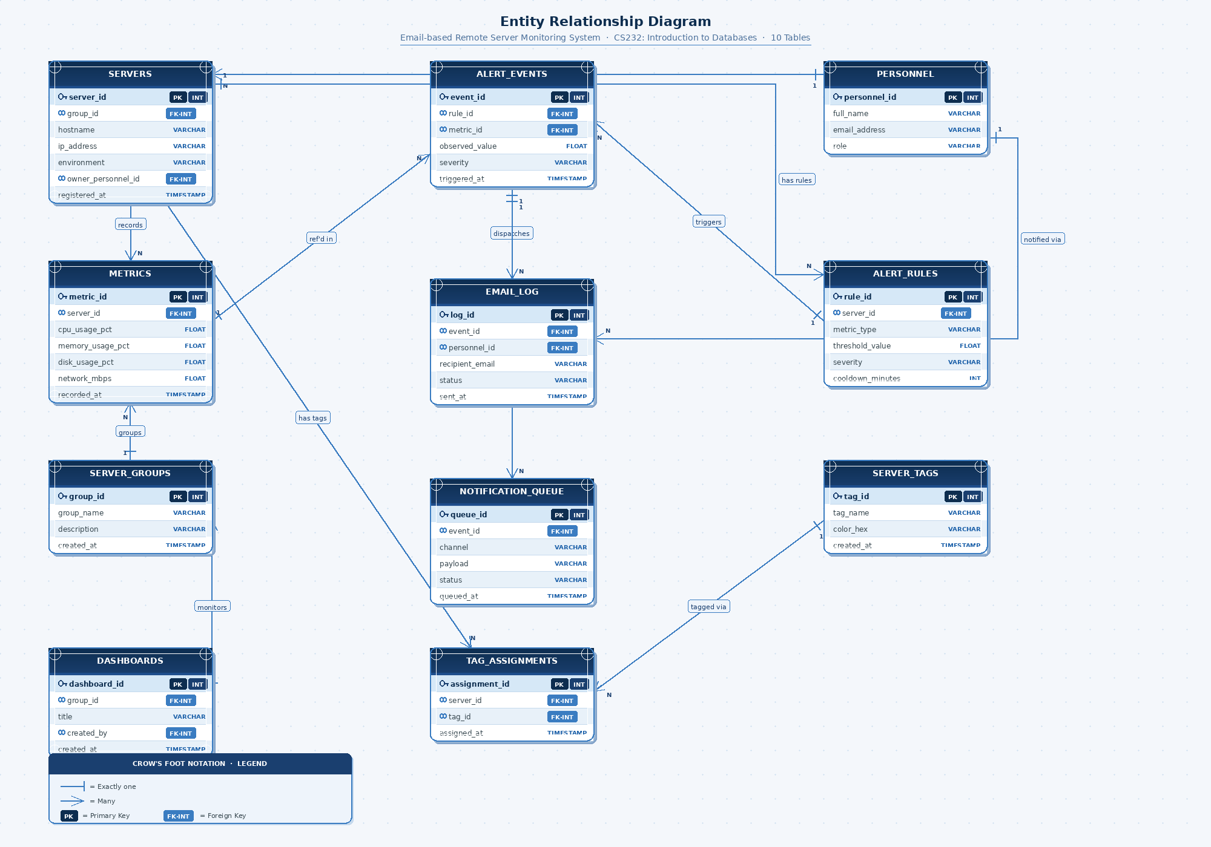

Table descriptions:
- Servers: Central entity — every metric and alert rule belongs to a server.
- Personnel: Administrators who receive email alerts; one person can own many servers.
- Metrics: Time-series performance readings (CPU, memory, disk, network) per server.
- Alert_Rules: Threshold definitions per server and metric type; drives all alert logic.
- Alert_Events: Immutable log of every rule breach, referencing both the rule and the triggering metric reading.
- Email_Log: Atomic dispatch record — written in the same transaction as Alert_Events to prevent duplicate emails.

7. Project Plan
The project will be executed in five sequential phases, each building directly on the previous. The points below outline the approach and key activities within each phase:

▌ Phase 1 — Requirements & ERD Design
- Finalize the business scenario and identify all data entities the system must track
- Design a complete ERD with cardinalities, primary keys, and foreign key relationships
- Review the ERD as a team and validate it against all functional requirements before moving forward

▌ Phase 2 — Schema Design & Normalization
- Convert the ERD into a logical relational schema, documenting each step from 1NF through 3NF
- Identify and resolve partial and transitive dependencies; target BCNF wherever feasible
- Write DDL scripts in PostgreSQL including constraints, indexes on high-use columns, and sensible defaults

▌ Phase 3 — Data Population & Query Development
- Populate the database with realistic sample data covering at least three servers and multiple triggered alert scenarios
- Write a core query library: metric snapshots by time range, top-N error events, per-server averages, alert frequency reports, and role-based views
- Implement stored procedures for bulk metric ingestion and alert dispatch workflows

▌ Phase 4 — Triggers, Transactions & Email Integration
- Implement AFTER INSERT triggers on the Metrics table that evaluate AlertRules and write to AlertEvents on breach
- Wrap AlertEvent creation and EmailLog insertion in a single transaction to guarantee atomicity and prevent duplicate email dispatch
- Integrate Nodemailer/Gmail in the Node.js backend for real email delivery; use mock handlers during high-volume testing

▌ Phase 5 — UI Prototype, Testing & Documentation
- Build a React dashboard displaying live server health cards, recent alert history, and a metric log viewer
- Conduct end-to-end testing: simulate threshold breaches and verify correct personnel receive email alerts without duplicates
- Compile the final project report covering ERD, normalization documentation, all SQL queries, and system architecture.

8. Use of DevOps principles
This project—an Email-based Remote Server Monitoring System—is deeply connected to the Operations and Continuous Monitoring phases of the DevOps lifecycle.
When covering core DevOps principles, such as those structured into interactive web-based quizzes, the focus often heavily emphasizes creating continuous feedback loops and automating infrastructure oversight. This project essentially builds one of those fundamental feedback loops from scratch.
Here is how the project specifically relates to foundational DevOps concepts:
- Continuous Monitoring: A core tenet of DevOps is maintaining real-time visibility into infrastructure health. Your system does exactly this by continuously collecting server performance metrics like "CPU usage, memory consumption, disk I/O, and error events".
- Automated Alerting and Incident Management: DevOps teams rely on automated systems to notify them of issues before users notice them. By triggering email alerts when thresholds are exceeded, the system delivers "immediate awareness to administrators without requiring them to be logged in or even at their desk".
- Observability and Capacity Planning: Beyond just reacting to downtime, DevOps (and Site Reliability Engineering) involves analyzing data to predict future needs. The project addresses this by persisting every metric and event so teams can "query historical trends, identify recurring issues, and plan capacity upgrades".
- Application of DevOps Practices in Development: The technical approach for building the tool itself utilizes standard DevOps practices. The proposal explicitly includes "Git / GitHub" for version control and "Jest" for automated testing, which are essential components of a CI/CD (Continuous Integration/Continuous Deployment) pipeline.
In essence, while the project is an academic database exercise, the end product is a custom-built, lightweight observability tool—a category of software that sits at the very heart of modern DevOps operations.

